The Hamburger Essay Plan

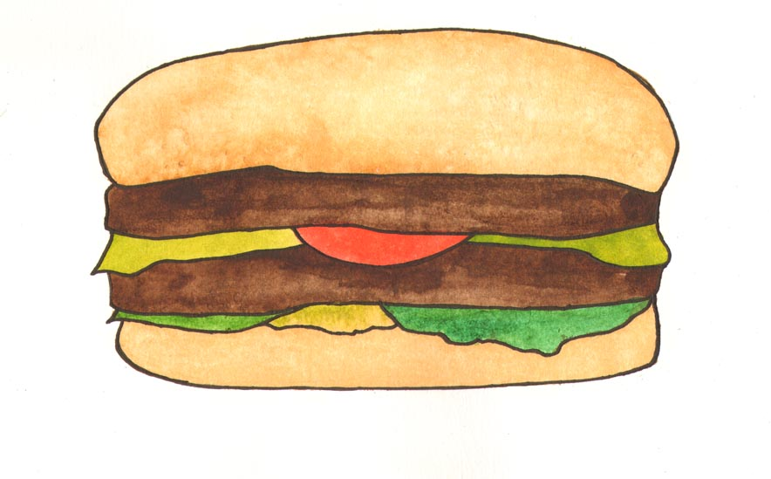

Think of any essay as a hamburger, and include all the key ingredients to make a great hamburger; link each one of these to a key point. This a particularly useful technique for exam essays as it can help you to check whether you have included all necessary information.

Gather all your ingredients – information that you have researched, class and seminar notes, readings…….now assemble the burger in the process illustrated on the next page down.

Top bun: the introduction
Describe how you are going to answer the question, summarise the key points you are going to make, reflect the question………..are you comparing and contrasting, arguing, describing?

Burger meat: the main points
You can make a double or triple burger, put in as much meat in your burger as you like. These are the main points of each paragraph.

Burger meat: the main points
You can make a double or triple burger, put in as much meat in your burger as you like. These are the main points of each paragraph.

Relish and garnish: the analysis
This is where you tie together the point, the example and the evidence and show how this relates to the question.
Cheese: the analysis
This is where you tie together the point, the example and the evidence and show how this relates to the question.

Bottom bun: the conclusion
In the concluding paragraph you should restate the points you have made, together with any inferences, conclusions or recommendations that can be drawn, linking these to the question.

